`GUJARAT TECHNOLOGICAL UNIVERSITY

Chandkheda,

Ahmedabad Affiliated



**Silver Oak college of Engineering and Technology**

A Report on

ENGINEERING FUNDA

Under subject of

DESIGN ENGINEERING

B. E. 3 Semester – 5

Computer Engineering

Group ID:

|  |  |  |  |  |  |  |  |
| --- | --- | --- | --- | --- | --- | --- | --- |
|  | **Submitted by:** |  |  |  |  |  |  |
|  | |  |  |  | | --- | --- | --- | | **SR NO.** | **NAME** | **ENROLLMENT NO.** | | 1. | KET PATEL | **160770107127** | | 2. | JULLY POPAT | **160770107175** | | 3. | JINESH PRAJAPATI | **160770107183** | | 4. | SAHIL RAJPUT | **160770107184** | |  |  |  |  |  |  |
|  | **Prof. RUHI VIROJ PROF.SATVIK KHARA** |  |  |  |  |  |  |
|  | **(Faculty Guide) Head of the Department(CE)** |  |  |  |  |  |  |
|  |  |  |  |  |  |  |  |

Academic year

(2018-2019)

**Silver Oak College of Engineering & Technology**

Computer Engineering

2018-2019

**CERTIFICATE**

**Date:**

This is to certify that the project entitled “**ENGINEERING FUNDA”** has been carried out by “KET (**160770107127**)”, “JULLY (**160770107175**)” and “JINESH (**160770107183**)”, “SAHIL (**160770107184)”** under my guidance in fulfilment of the Degree of Bachelor of Engineering in **Computer Engineering** – 5th Semester of Gujarat Technological University, Ahmedabad during the academic year 2018-2019.

|  |  |
| --- | --- |
|  |  |

**PROF.RUHI VIROJ PROF.SATVIK KHARA**

Head of Department

(Computer Engineering) (Computer Engineering)

**CANDIDATE’S DECLARATION**

We have finished our project report entitled **“ENGINEERING FUNDA**” and submitted to our respective guide. We are in 3rd semester and we have tried to give our best. We have done our work honestly and in a good way.

|  |  |
| --- | --- |
|  | :**KET** |
| First Candidate’s Name |
| Branch | : ​**CE** |
| Enrollment No. | : ​**160770107127** |
| Signature | : |
| Second Candidate’s Name :​**JULLY** | |
| Branch | : ​**CE** |
| Enrollment No. | : ​**160770107175** |
| Signature | : |
| Third Candidate’s Name | :​**JINESH** |
| Branch | : ​**CE** |
| Enrollment No. | : ​**160770107183** |
| Signature | : |

|  |  |
| --- | --- |
| fourth Candidate’s Name | :**SAHIL** |
| Branch | : ​**CE** |
| Enrollment No. | : ​**160770107184** |
| Signature | : |
|  |  |

Submitted to: **Silver oak college of engineering & technology, Ahmedabad.**

Affiliated to: **Gujarat technological university.**

**ACKNOWLEDGEMENT**

We would like to extend our heartily thanks with a deep sense of gratitude and respect to all those who has provided us immense help and guidance during our project.

We would like to express our sincere thanks to our internal guide **Mrs. RUHI VIROJ** for providing a vision about the system and for giving us an opportunity to undertake such a great challenging and innovative work. We are grateful for the guidance, encouragement, understanding and insightful support given in the development process.

We would like to extend my gratitude to Head of Computer Engineering Department, Silver Oak college of Engineering and Technology, Ahmedabad, for his continuous encouragement and motivation.

Last but not the least we would like to mention here that we are greatly indebted to each and everybody who has been associated with our project at any stage but whose name does not find a place in this acknowledgement.

Yours Sincerely,

​

**KET (160770107127)**

**JULLY (160770107175)**

**JINESH (160770107183)**

**SAHIL (160770107184)**

**ABSTRACT**

Engineering funda is a tool which connects student to proper relevant data as per their requirements. It also provides faculties to connect with the students with proper content. It also provides expert connectivity. Some important questions and answers are also provided here.also some frequently asked questions are also provided here.

|  |
| --- |
| **TABLE OF CONTENTS** |
|  |
|  |
|  |
|  |

**Sr. Topic Page no.**

**1 Chapter 1. Introduction 1**

1.1Dessign thinking and its importance 1

1.2Project summary 1

1.3Scope 1

**2 Chapter 2.Literature Review /Secondary Research 4**

2.1Literature review 4

2.2Technology and tools 5

**3 Chapter 3.Design consideration 6**

3.1Design for performance, safety and Requirements 6

3.2design for ergonomics and aesthetics 7

**4 Chapter 4.System requirements 11**

4.1 Functional Requirements 11

4.2 Non-Functional requirements 11

4.3Hardware Requirements 11

4.4software requirements 11

**5 Chapter 5. Data Modelling 12**

5.1 E-R Diagram 12

5.2 Use Case Diagram 13

5.3Sequence Diagram 14

5.4State Diagram 15

**6 Chapter 6. Data Dictionary 16**

**7 Chapter 7. Prototype 18**

7.1UI Design 18

**8 conclusion 24**

8.1 Conclusion 24

8.2Future Work 25

**List of Figures**

**Sr. Topic Page no.**

1 Figure 5-1 – ER Diagram 12

2 Figure 5-2 – Use Case Diagram 13

3 Figure 5-3 – Sequence Diagram 14

4 Figure 5-4 – State Diagram 15

5 Figure 7-1 – UI Diagram 18

**List of Tables**

**Sr. Topic Page no.**

1 Table1 – Database 16

2 Table 2 – User Information 16

3 Table 3 - University Information 17

4 Table 4 – Course Information 17

**Chapter 1. Introduction**

* 1. **Engineering funda and its importance**

Engineering funda is a process where we are to select a domain to make it better. Better in any sense one would think it could have been better regardless of its importance to one person. Solving complex problem requires analysis and design thinking. There is always room for improvement and hence, innovation. Innovation can’t just be done overnight and therefore, require planning and various designing aspects. Design should not be problem-focused it should be solution focused i.e. solution should be given utmost priority, to create desired outcomes that benefit user

* 1. **Project summary**

Engineering funda has shortened the distance of student from good content.It drawn a great deal of attention in the field of distance and continuing education The types of available technologies used in distance learning are divided into two groups: synchronous and asynchronous. One of the main advantages of Engineering funda is that web-based courses can be accessed at any time or place feasible.

* 1. **Scope**

**Chapter 2.Literature Review /Secondary Research**

**2.1Literature review**

Online content providing & number of potential benefits, not least of which is the ability to overcome the temporal and spatial restrictions of traditional educational settings. Advantages that online learning offers, a variety of factors have been identified as crucial to the success of proper content motivation is one such factor. Just as motivation is a key factor in learning and achievement in face-to-face educational contexts so it is in online learning environments. Now a day’s more students are coming from rural areas and it’s not possible to stay in cities for their education. This project can help them to improve their qualification as well as their knowledge. Here all students can register through this index web page and search available coerces and books in the database. This project mainly consists of website management module, new user (student) module, University names module, lecturer’s module. The importance of self-assessment through tools made available on Educational Technology platforms has been growing. Self-assessment in education technology relies on students analysing their strengths, weaknesses and areas where improvement is possible to set realistic goals in learning, improve their educational performances and track their progress .

**2.2Technology and tools**

**Chapter 3.Design consideration 3.1Design for performance, safety and Reliability**

**DESIGN:**

design is very simple any one any body can use this at any time.by just writing their username and password they can access it soonely. Faculties can provide important content to the student directly. Also it is easy to access by student and to ask questions here.

**PERFORMANCE:**

Performance is very efficient as anyone can access it and mostly for as student gets perfect and appropriate answer for their question.

**RElLIABILITY:**

Learners will not trust any site or content directlt they have search for answer at various websites and google in various content and read it.while it provides content approved by faculties.

**3.2design for erg**

**Chapter 4.System requirements**

**4.1 Functional Requirements**

**4.2 Non-Functional requirements**

**4.3Hardware Requirements**

**4.4software requirements**

**Chapter 5. Data Modelling**

**5.1 E-R Diagram** Entity – Relationship Diagram is a first step to identify the entities related to our project andhence, needed to be improved or used optimally. ER diagram helps us to establish relationsamong entities and how to use them properly

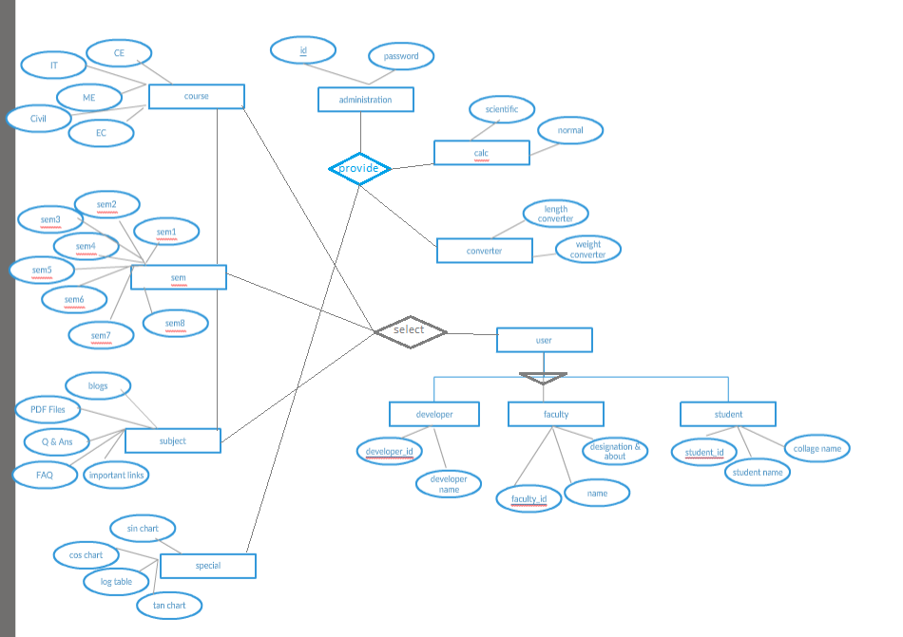

**5.2 Use Case Diagram**

Use case diagram is primarily made to identify users and their requirements. These can easily be done by creating Use Case diagram. Use Case diagram also helps to identify factors that might influence or change the system

|  |
| --- |
|  |

**5.3Sequence Diagram**

After understanding requirements, entities and relationship between among them, it is very

essential to figure out how they interact with each other. These interaction can easily be

identified by using sequence diagram. Sequence diagram is used to show interaction between

objects.

|  |
| --- |
|  |

**5.4State Diagram**

**Chapter 6. Data Dictionary**

User information:

|  |  |  |  |  |
| --- | --- | --- | --- | --- |
| **Attributes** | **Description** | **Data type & Size** | **Required** | **Accept Null Values** |
| Name | To identify user | VARCHAR2 | yes | no |
| User ID | To know the user | VARCHAR2 | yes | no |
| Collage name | To know the student from where he is | VARCHAR2 | yes | no |

**Chapter 7.Prototype**

**7.1UI Design**

**Chapter 8.Conclusion**

**8.1 Conclusion**

**8.2 Future Work**